Creative Writing

**The craft of plot**

* Freytag’s Pyramid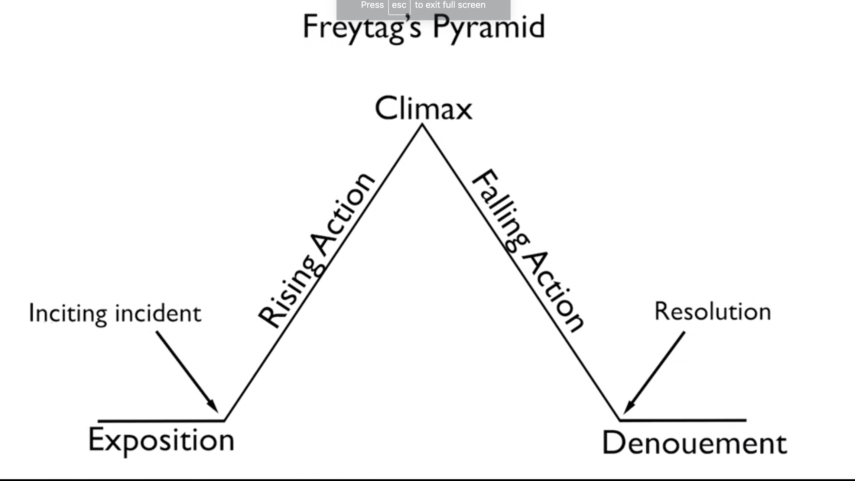

**Exposition**: Setting character, background

ex: Harry’s background

**Inciting action:**

Letter from background

**Rising action:**

Friends and Hogward’s life.

**Climax:**Fight with Voldy  
  
**Falling action:**

Mother’s love, explanation by Dumbledore

**Resolution:**Gryffindor wins

**Denouement:**

Comes back but Dursley’s don’t know he cannot use magic  
  
Goblet of Fire:

Exposition: Waking with hurting scar, triwizard tournament announcement.

Inciting incident: Choses as triwizard

Rising action: Tournament tasks

Climax: Graveyard, Peter Pettigrew, Voldemort’s rise

Falling action: Mad-eye is Barty Crouch. Harry is declared as winner.

Denouement: Harry gives money to Weasleys to open joke shop. None at the ministry believe Voldy is back.

Deathly Hallows:

Exposition: Harry turns 17, DeathEaters fight

Inciting incident: Wedding, Trio escape

Rising action: Hunting down the horcruxes, fighting with DE, captured to Malfoy Manor

Climax: Harry offers himself to Voldy

Falling action: Harry pretends dead and then reveals himself alive, real battle

Resolution: Harry asks Voldy to feel sorry. Voldy fires killing curse, Harry bounces with disarm curse.  
Denouement: Harry sends his kids to school.

**Character + Action = Plot**

*You don’t depict fate, you depict will.*

**5 key questions to create a great dynamic character:**

1. What do they want? - This is different from what they need. What they need is fate, what they want is desire
2. What are their weaknesses? - Their weakness makes them interesting. Make sure weakness is more interesting
3. Where are they from? - This question helps us understanding the character. Geographically, emotionally….
4. Where are they going?
5. What can a character do to surpass you?

**Inciting Incident + The Obstacle + A character + The quest = Book**

**The 5 act structure:**

Alice Adams five act structure:

1. Action - physically doing something
2. Background - before the story started, the details
3. Development: Main plot, rising action
4. Climax: Biggest, rising plot
5. Ending:

Example of 5 act structure in Sorcer’s stone:

* Action: Knowing through letter that Harry is wizard
* Background - Voldy murdered his parents
* Development - Time in hogwards, Hermy,Ron, Snape
* Climax - Quirrel is Voldy
* Ending - Gryff winds

Blind writing:

Writing certain number of pages or hours without particularly interested in where one is going.

**What is Scene?**

* Argument
* Seduction
* Negotiation

**SHOW DON’T TELL**

**5 things a good scene needs:**

* Action - something has to happen, not dreaming or reminescing
* Dialogue - never just convey information, but must:

* depend our understanding of character

* advance the plot

* Specific intimate details - the kind of details the reader may not notice without your help
* Inner point of view - react, reflect, reveal
* Definite starting and ending point - great scenes start with an action

Story: An iterneray of events that has occurred that do not have relation to one another

Plot: Series of events linked casually to one another

Writing fiction is kind of similar in trying to tell someone a half remembered dream.

Transform your dream from your head to the reader. Can you write in scenes about the atmosphere, logic, sensory details. If you can’t, the reader cannot deliver the pleasure of reading.

Setting is not ornamental, it is integral.

The characters and plot without the setting may not give the same story.

**EDIT:**

You only get one shot to introduce yourself to agent.

**Most books don’t sell because they are not ready to be shown to others, don’t let that happen to you.**

*Don’t rush through revisions because you are eager to sell.*

**21 Point checklist for editing**

1. Start with easy fixes - Grammar check, typo
2. Omit needless words
3. Cut where you are doing the reader’s thinking for them (Show don’t tell)
4. Cut stage direction - where a character is standing, how many steps needed to get there
5. Insure consistency
6. Has an action happened in the first paragraph or chapter?
7. Is my story coherent? Details consistent?
8. Are the scenes complete?
9. DO I start each scene with something active?
10. Am I writing in active voice? - Have I avoided passive voice and parallel construction using the same, word over and over. “There is, there are, it is, made his way” - You are probably using passive voice, if you are using the above
11. Is setting working? Should should be an integral part of the story. If the story can be set anywhere that’s not an effective way to tell a story.
12. Are my character acting belivably?
13. Are the transitions between paragraphs clear?
14. Dose my story fit together? ( Action, Background, Development, Conflict, Climax, End)
15. Did I explain to readers every risk involved in the characters?
16. Did I explain the consequence of the risk?
17. Did every sentence deepen character or advance the plot? - Any sentence that fails to, should be cut.
18. Is 2nd draft, 10% shorter than the first?
19. AmI ready to discard pages that are’t working?
20. Is what you mean on head clear on writing?
21. Get feedback and address them.

* While asking for feedback, be very specific.
* After finishing whole manuscript, find outside readers. Give few chapters first and get them to answer few specifics questions.
* Do not give them the whole manuscript and say, tell me what you think
* What did you think of the main character or the action in chapter 1?
* Were the main characters of chapter 3 hard to follow or confusing?
* Locate a scene and mark 5 points that a scene should have.

Revision:

Not to feel , “Oh! Dear! That didn’t work, “I need to stop”, but instead to say, “thre was one little glimmer in there, and that was a good idea” and now I have to fan that and bring it to life and make it a whole light.

**The craft of character**

**Essential to build character:**

* Observation and Empathy
* You don’t have to describe somebody, you actually have to try to be them

Bad people don’t think of themselves as bad people, enter the psyche of the characters you create.

**Conception of characters:**

* Physical being: how do they look like, top to toe, tall or short, face structure, specifics, accent. The reader should be able to see them, hear them, smell them.
* At the core of character is writer’s feelings
* Include all aspects of the character, the good, bad, ugly
* Just as how the desires and longings of humans dictate humans life, knowing the desires and longings of characters helps us write better.
* To build characters : know their quirks - do they bite their hair when they are anxious, do they wiggle their legs when they are anxious, do they have a pet? What pet do they have? What is by their bedside? Do they still indulge in some childhood activity, if yes, what is it? What type of clothing do they wear? (what do they tell about them) are they a reader?
* **The 25 questions to know one another, try that with the character**

**Writer’s are often suggested to read their work aloud, to distinguish between what’s working and what should be cut.**

When you read loud, you find that you are really bored with some pages or you want to read something over and over again.

**Journalism is responsible for the facts and fiction is responsible for the truth.**

**Dialogue:**

* An excellent way to convey rising action
* Not a place for exposition
* Active and moves the story forward.
* How, what, when a dialogue is delivered - builds character
* Important thing about the dialogue is what it reveals about the speaker.
* Instead of saying someone is kind, narcissist. You give them a dialogue through which the readers get to know that they are kind.
* When you are writing a particular dialect, say it out loud and make sure what you have written is what the reader will be hearing. Listen to the way real people of the region are speaking. Don’t write in a dialect unless your ear is really good

A character who want something will DO as opposed to character who need something, who would resign on fate.

Try to write the characters from first person ( the character itself), as third person as author. Will help you understand the character better and get perspective.

When you are stuck with the character, not knowing how to proceed, introduce a new character. Enter into the character and think like that character.   
  
Hw: Do different kinds of characters.

**Entering the story through different ways:**

Writing a story could be analogous with entering a house. You can enter through front door, enter through back door, swing in from free. Similarly, see the story from different perspectives from that of the protagonists, antagonists etc.. Give yourself freedom to approach your characters and story in wider range as possible, till you find the one that gets you inside the story where you want to be.

Requirement of a writer is to show, show and show some more and then tell a little bit.

Recommended Read:

Sterring the craft - Ursula K Le Gein

Bird by Bird

The art of writing - Stephen King

The art of character by David Corbett

The Elements of Style by William Strunk Jr.

Don DeLillo, Grace Paley - great dialogue writer

Mystery and Manners by Flannery O Connor

Remember what to cut out:

the wordy, the meandering, the unduly analytical

the parts of speech that aren’t nouns and verbs—unnecessary modifiers, redundant prepositions, and so on

throat-clearing or mealy-mouth words or phrases: “just,” “like,” “sort of,” “kind of,” “almost,” “very” . . .

the teach-y, the explain-y, the crying out, the condescending

*Ever tried, ever failed, no matter try again, fail again, fail better.***Inflection:**

Important for characters to have distinct voices, that the reader can identify who is telling the story.

**Idiosyncrasies**:

Dialogue that is written should be as spoken, but not too many lexical fillers.

But if you write everything that is spoken, then it would be boring.

**Many beginning writers use many adverbs.**

“I hate your guts.” Bill said, ~~angrily~~.

“I hate your guts.” Bill said, sweetly - ✓

In the latter case the adverb changes the meaning of the sentence. In such case it adds value to use adverb.

*An award winning writer used to listen to a music piece of flies buzzing to be irritated and write the life of African woman.*

To write amazing character you need not fall in love or empathise with the character. You would have to know the character very well.

**Narrator** - it could be the writer or anyone in the story ( POV: Point of View )

* 1st person POV
* 3rd person POV
* Omnipresent POV

**The craft of Setting:**

* In order to write well, you should be persuasive, convincing. Reader should believe
* Suspension of disbelief - the faith the reader is willing to extend.
* Detail and setting is significant
* The more specific the detail, the more universal.
* For writing better about a setting, try to write about the setting as if you are in the setting for the first time.
* Nothing can happen no where. The locale of the happening always colours the happening and often to a degree shapes it.

**Research for setting**

1. **Functional**: Actually going to the place, meeting characters. Googling about the place
2. **Inspirational**: Intuitive. Listening to music and reading poetry that helps us set the setting.
3. **Imaginative**: Envision the world you describe.

“I went to Europe 3 times, I read dozens and dozens of books, I studied 1000s of photos. But I always supplemented my research with imagination”.

- Author of the best selling novel, “All the light we cannot see.”

Research might give you detail, but imagination supplies the direction in which to apply all that detail.

For me writing historical fiction is all about finding a balance between reading, traveling, cooking, imagining and dreaming.

**Litmus test for setting;**

* The setting should save the story
* Who is seeing the setting, depending on that the details would vary.
* Who is saying it, the writer or the character.

The setting and the character should be second nature to the author, the author should feel very comfortable stepping into the fictional world.

If you want to write about bombing, you should be able to see it, smell the smoke, feel the people crying. You should be willing to enter the world, if you are not, then don’t write it.

Reading poems could inspire to write fiction and put you in the correct form and mood.

**Cliches and stereotypes mostly results in bad writing.**

“Nothing that is human is aliens to me”

- Tevence

If you believe in this, then you can and should write about every kind of human experiences, not just your own.

**Historical Setting**:

* Lots of people research so much about the region, land, technology during that time without spending much time on the character’s psyche.
* Read letters and journals of that era to get into the characters.
* Read fiction of that time.
* Do not force the information upon the reader.

ex: This cup was made by such and such person in such and such town in Britain in 1418 and here it is 60 years later and I am drinking from it. - BIG NO

**The craft of style:**

The difference between the right word and the most right word is difference between a lightning and a lightning bug.

- Mark Twain

“If I read a book and it makes my whole body so cold no fire can warm me, I know that is poetry. If I feel physically as if the top of my head were taken off, I know that is poetry. These are the only ways I know it. Is there any other way?”

- Emily Dickinson

Only when we write in a sensual way, it makes appeal to the senses, it feels real.

Denotation: Literal meaning

Connotation: he meaning that goes with denotation.

Acknowledgement of the reader:

A lot of beginning writers need to realise that there is someone on the other side. You need to consider what the reader is able to intuit, what the reader needs, what the reader gets stuck on.

There is someone with whom they want to be honest, there is nothing more frustrating than have a story misunderstood. It is frustrating to do all that work by yourself, choose all these words and then people are enraged or misunderstood, it might happen if you are unclear.

Be mindful and deliberate of the word choices.

“Old fashioned pen” - Idea.

“green fountain pen.” - without telling the reader it is old fashioned, you are showing them.

Being forced to try often makes you attack every weak adjective and adverb in the piece. Writing is a concentrated form of thinking.

One preposition will always do

Recommended Read:

Books by James Salter - American Novelist who was a war pilot, wrote a book that sold well that he quit being a pilot.

New Yorker’s fiction podcast - Light year

prime of miss jean brodie - Muriel Spark

Only that which does not teach, which does not cry out, which does not condescend, which does not explain, is irresistible

- William Beats

* Always remove just, thoughtfully.
* Remove as much adverbs as possible. Adverbs show that you are amateur. They dilute your writing. Ex: He sat down because he was tired. - Not good He sat down. He was tired. - Good
* “So” when used as an amplifier of what?
* Avoid “then”, it is implied that the second line follows.
* Likewise, avoid “Somehow”
* Never begin a sentence with “it”
* Remove meandering and lexical fillers
* Unnecesarrily analytical commenting can be removed.
* Never use more than one preposition together
* Try to avoid adjectives with better words. “Paced madly” - find better word
* Remove explanations - SHOW DO NOT TELL.
* Experiences are good narratives, ideas are not good narratives
* Simply inner dialogue and implicit narration are redundant - add dialogues to SHOW instead.
* Explosion of feelings/emotions makes the reader back away. (If the character cries but the reader doesn’t cry then they loose interest)
* Explicit interior monologue to describe feelings - Bad Idea. Instead, could try: “He reads her messages again and again. He goes to shop buys her groceries for her favourite food. Calls the carpenter to hang swing.” - Indirectly telling he is in love.
* Write the story, not the story and it’s interpretation.
* Reader’s feelings, ideas and interpretation - writer’s should respect and not get too much into these.

The more words you can eliminate, the better of everyone is